FastAPI - A python framework

Link: <https://www.youtube.com/watch?v=7t2alSnE2-I>

Sumário

FastAPI INTRO 2

Course Intro 2

Install and Setup 2

Break it Down 2

Path Parameters 3

API DOCS 3

Query Parameters 3

Request Body 3

Debugging 3

Database Conection 3

Store blog to database 3

Load Blog from database 3

Exception and status Codes 3

Delete a blog 4

Response model 4

Create a User 4

Hash Password 4

Show User 4

Using Doc Tag 4

Realtionship 4

API Router 4

API Router Pathb Operators 4

Blog & User Repository 4

Login & Verify Password 5

JWT ACCESS TOKEN 5

Route Behin Authentication 5

Deploy FAST API app 5

# FastAPI INTRO

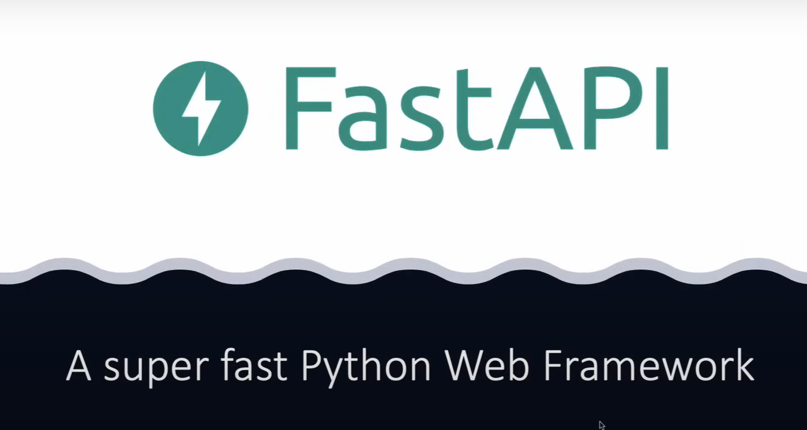

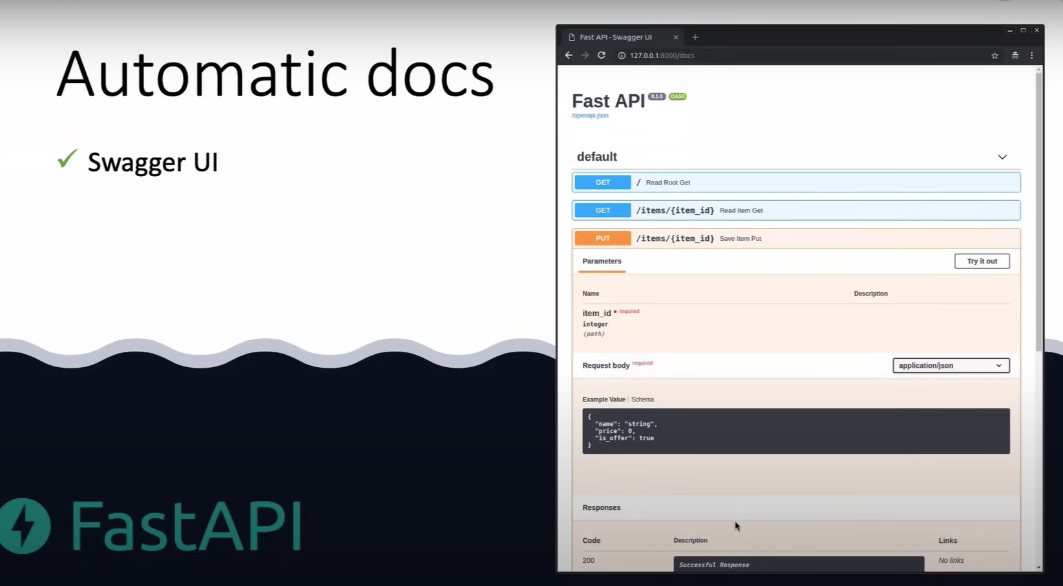

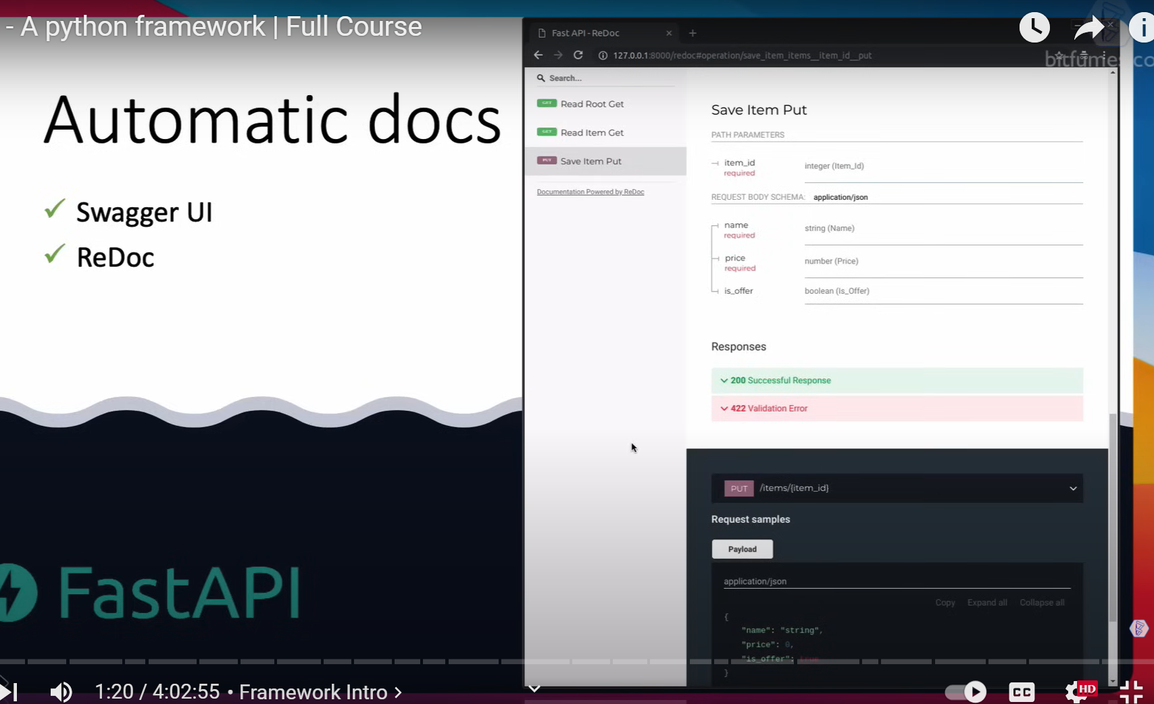

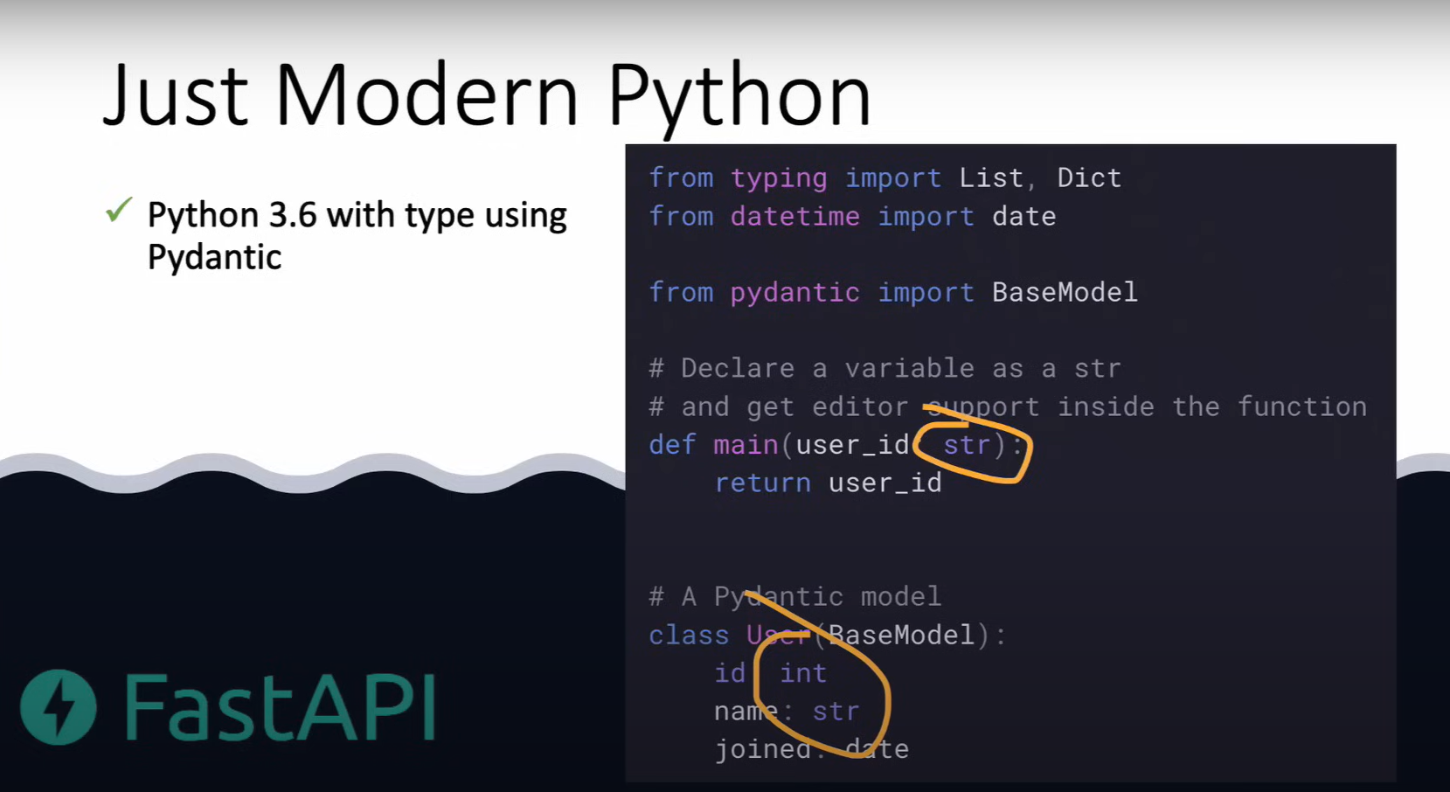

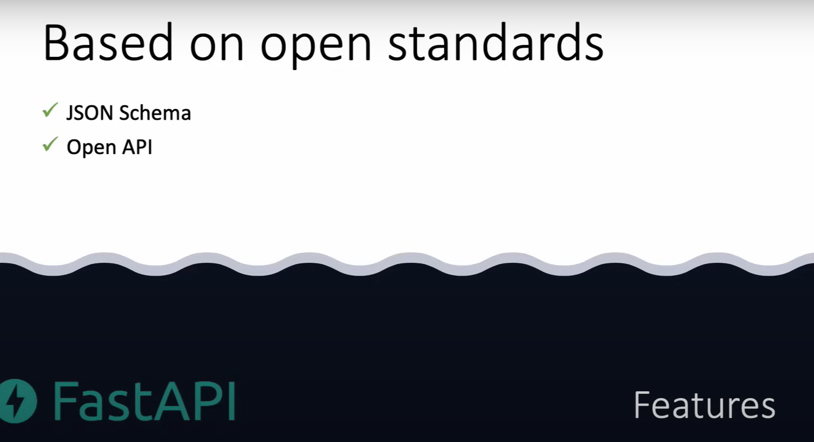

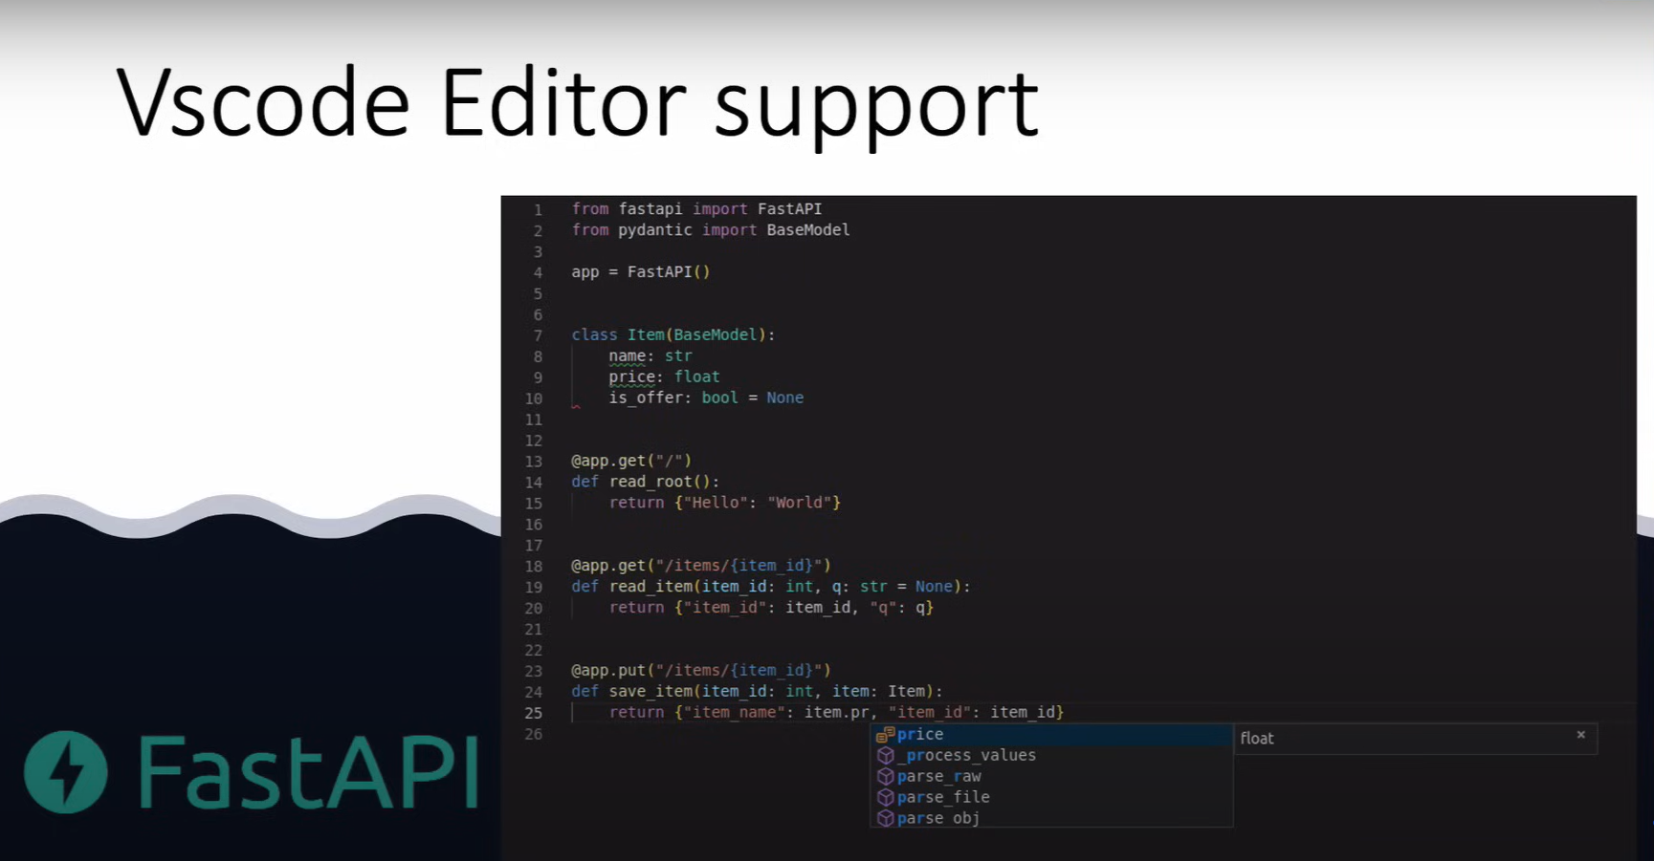

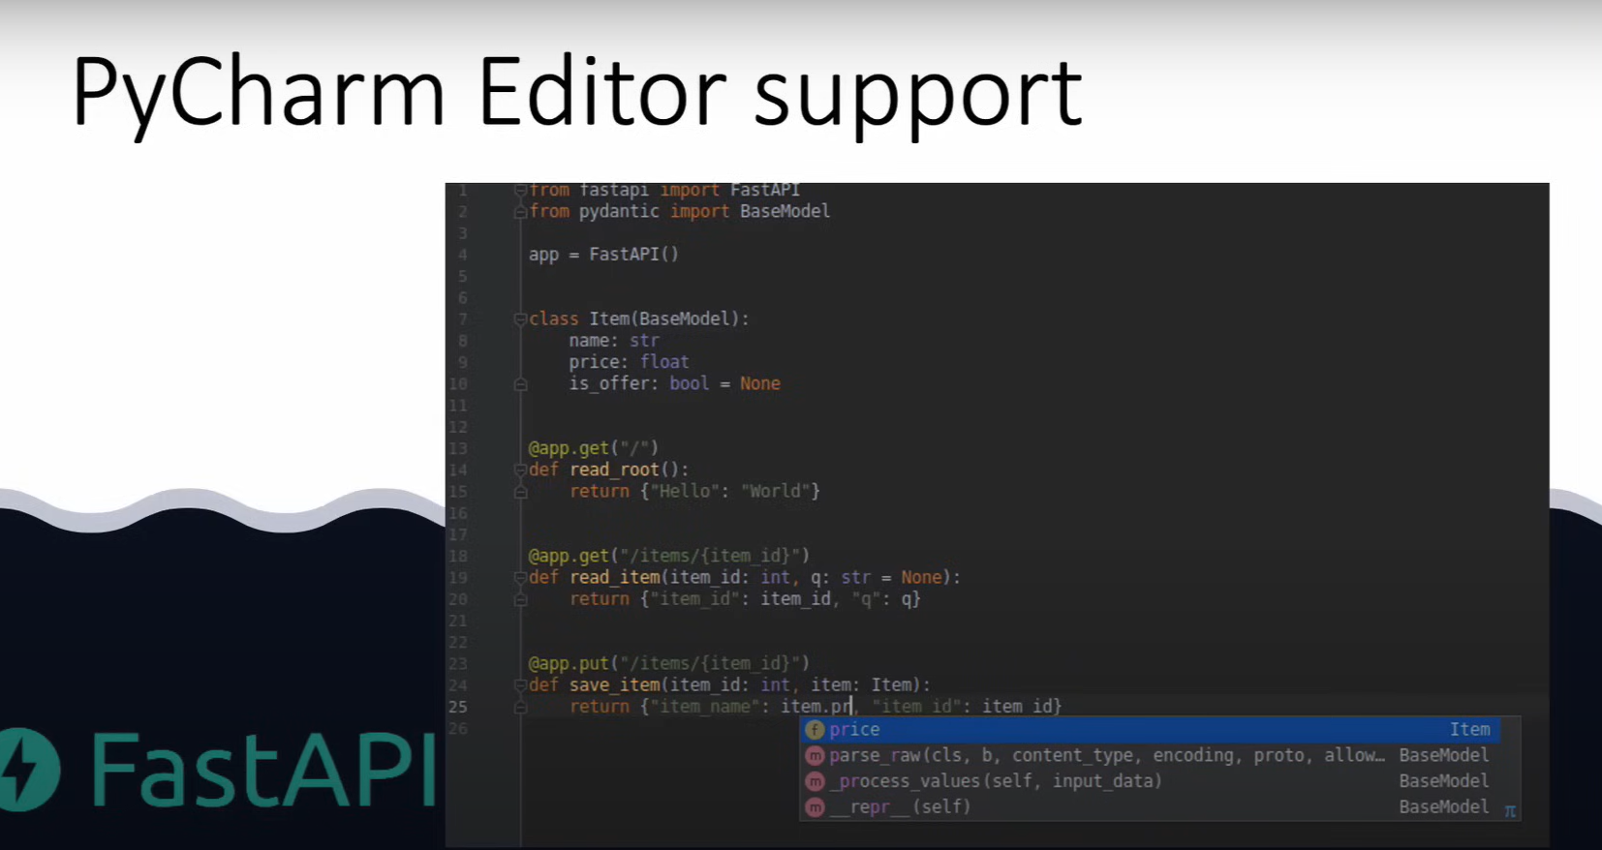

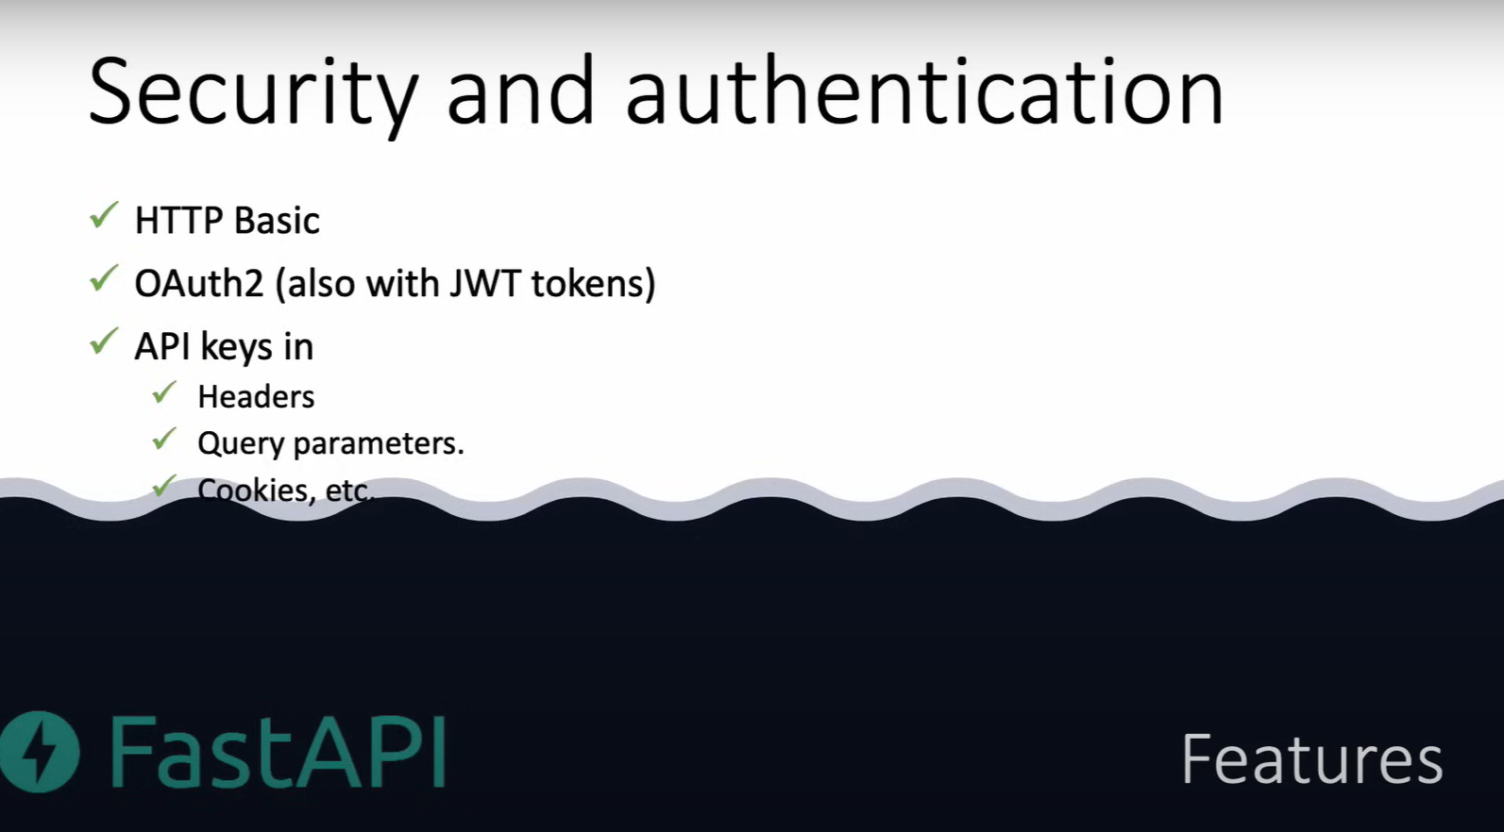

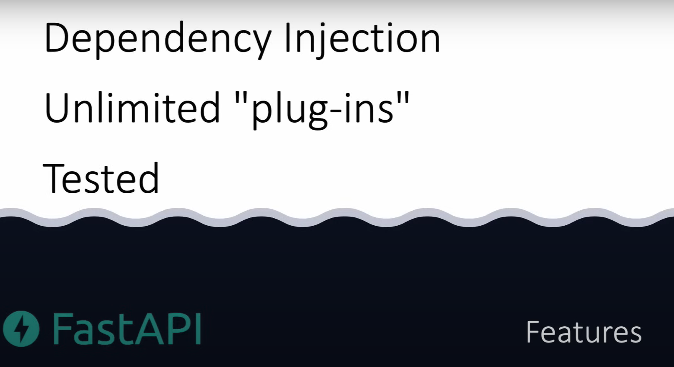

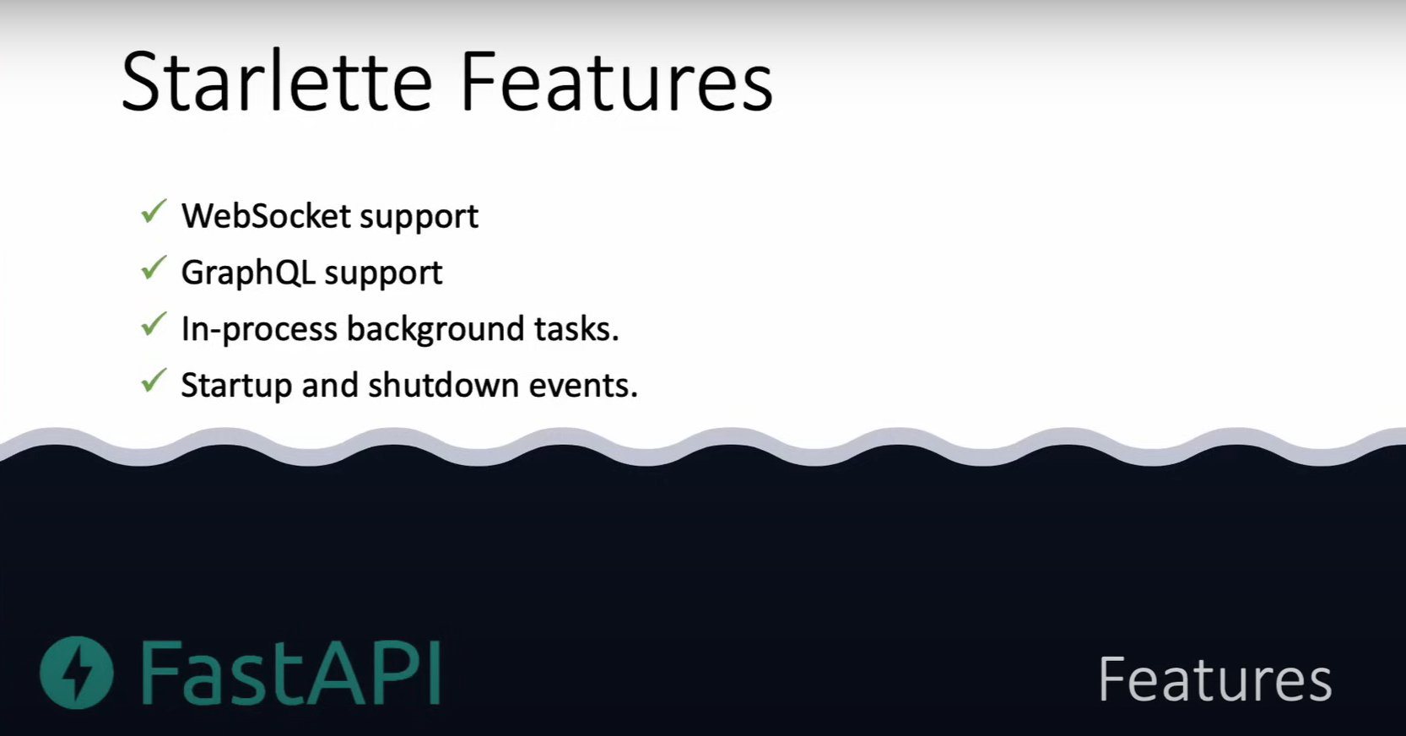

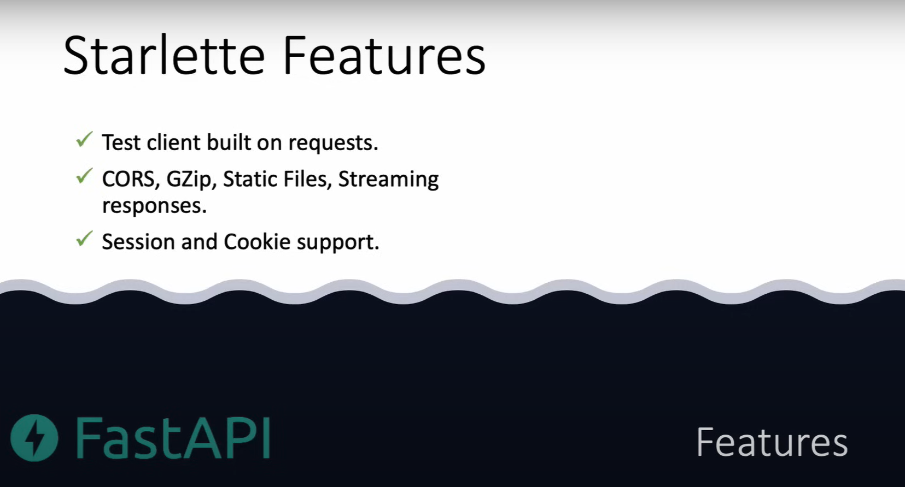

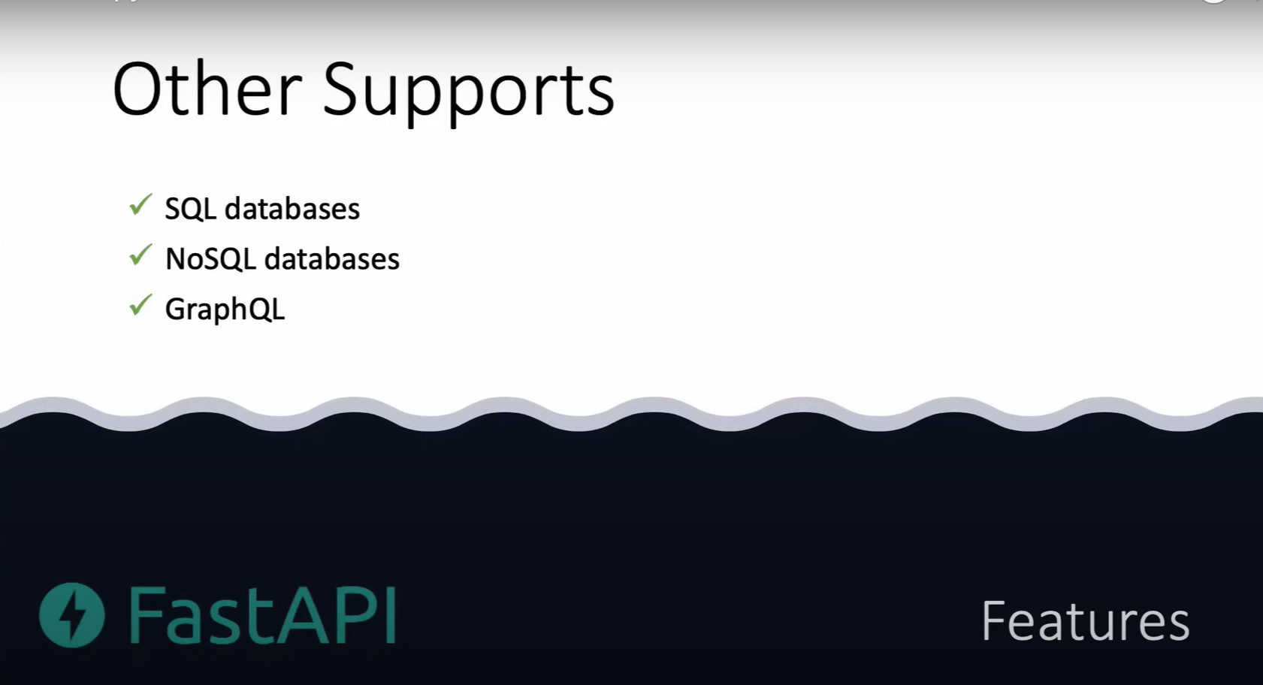

# Course Intro

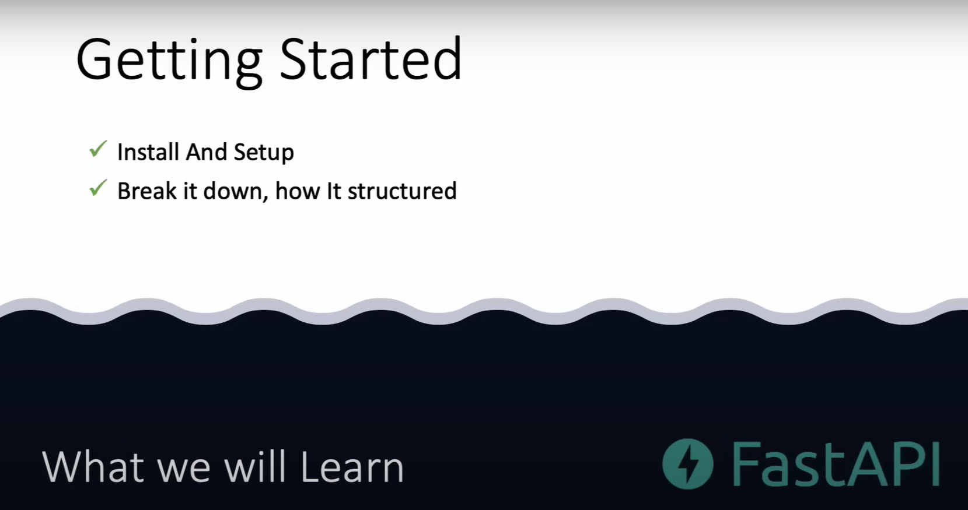

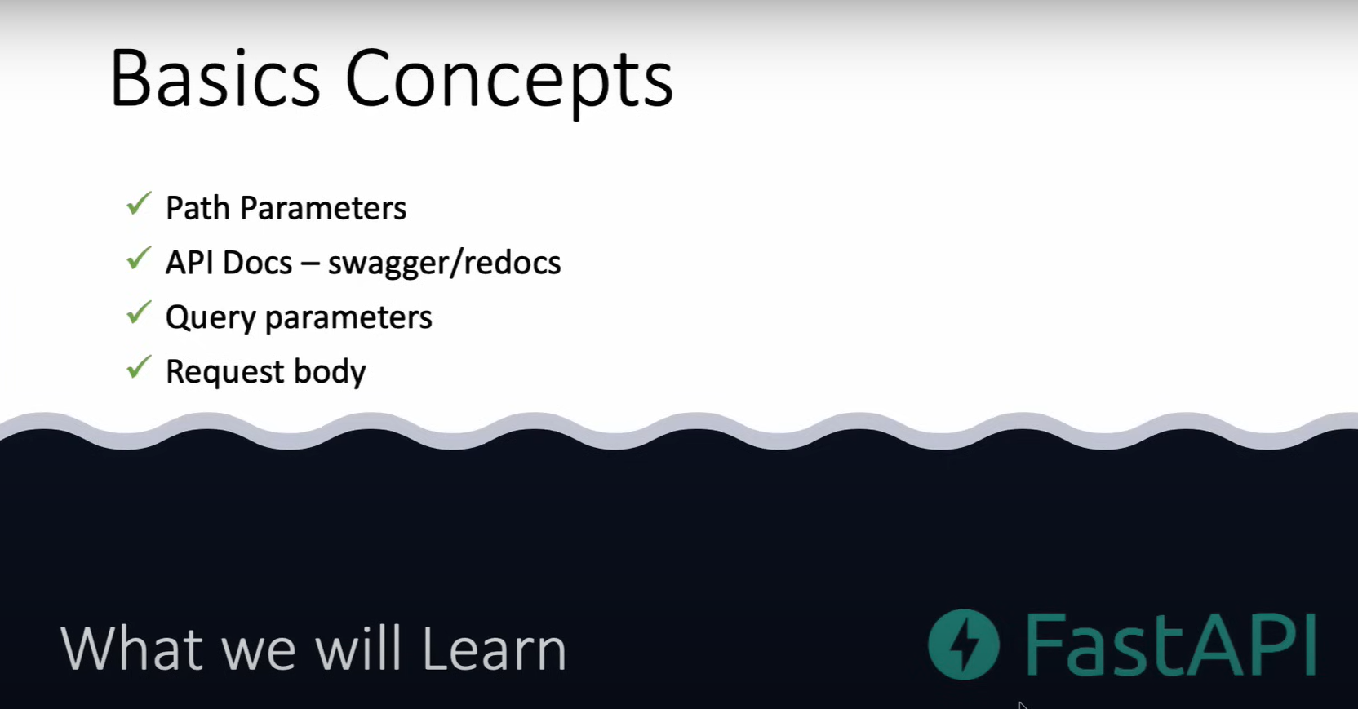

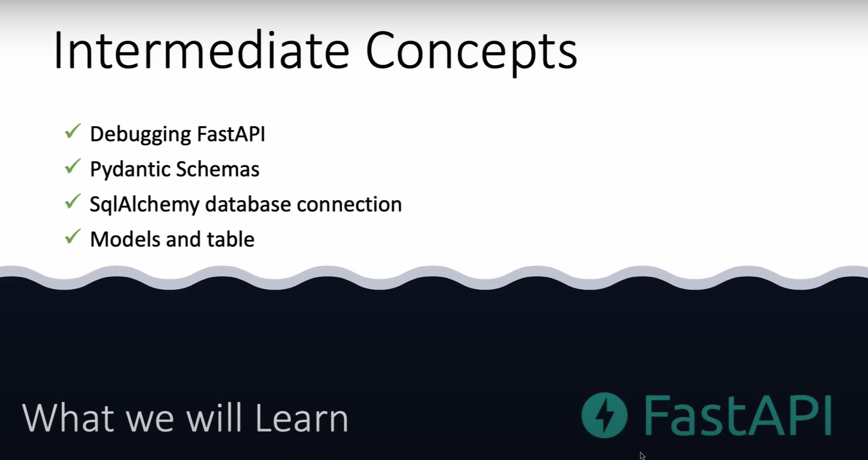

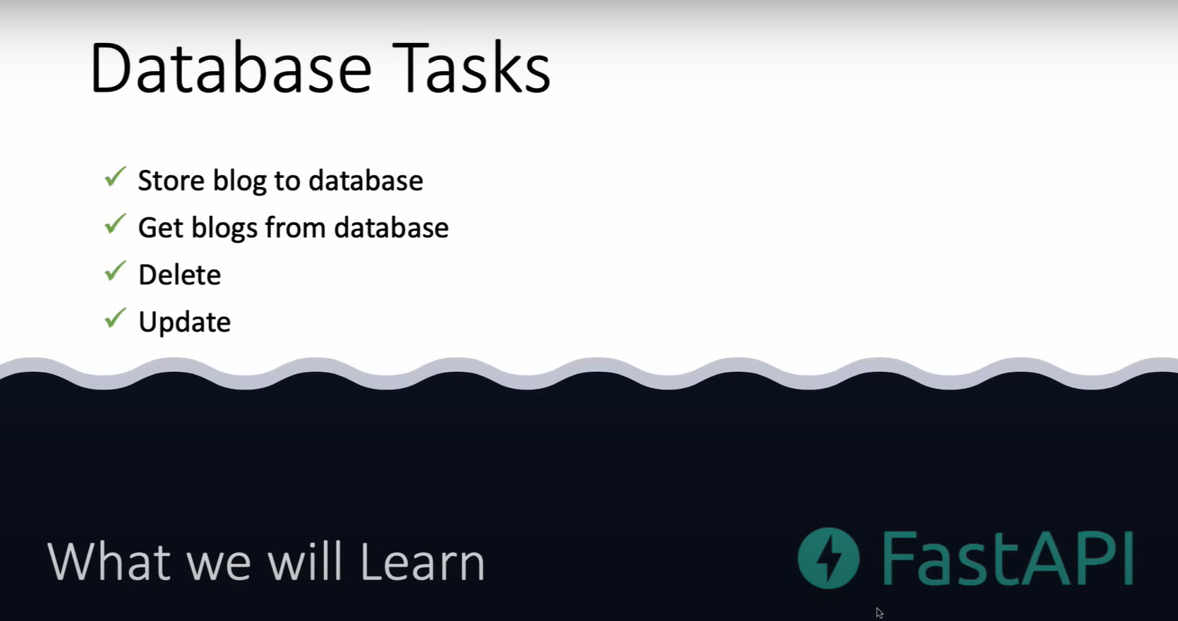

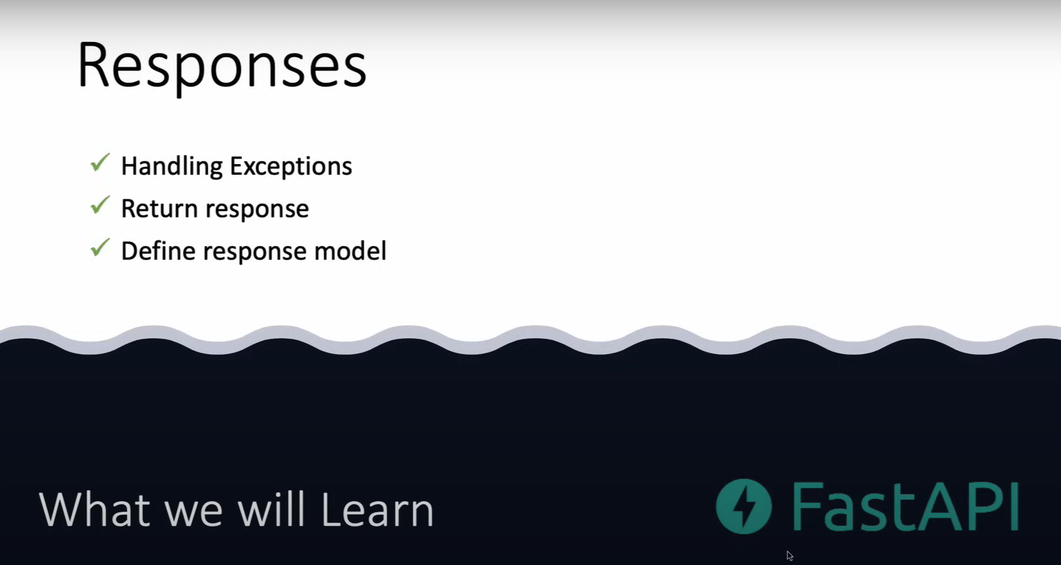

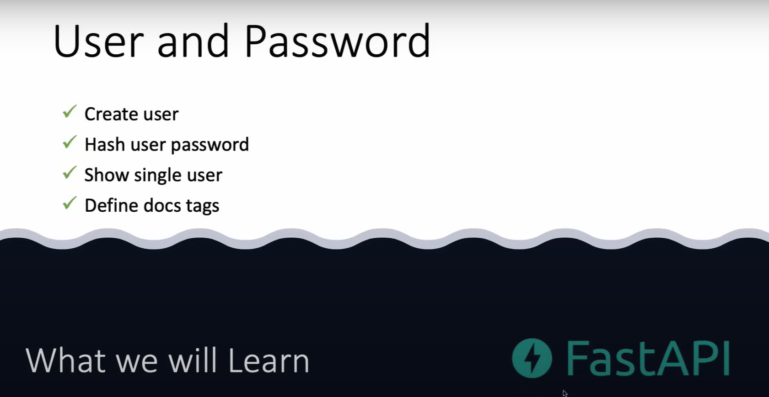

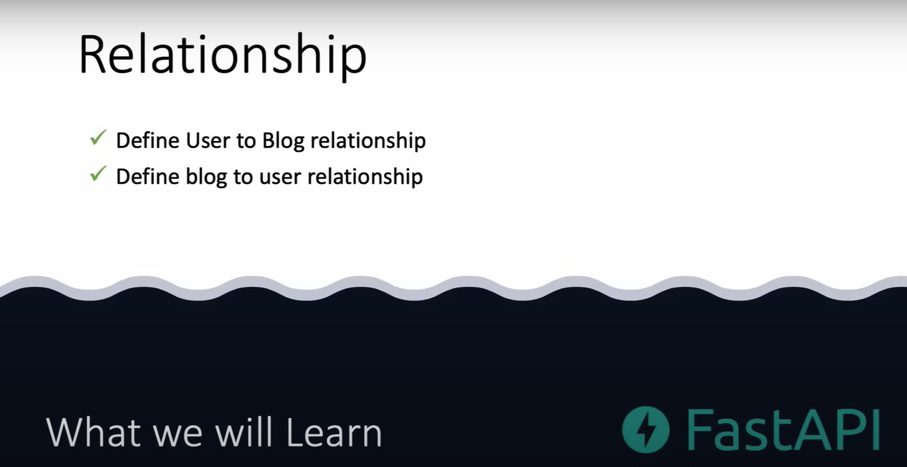

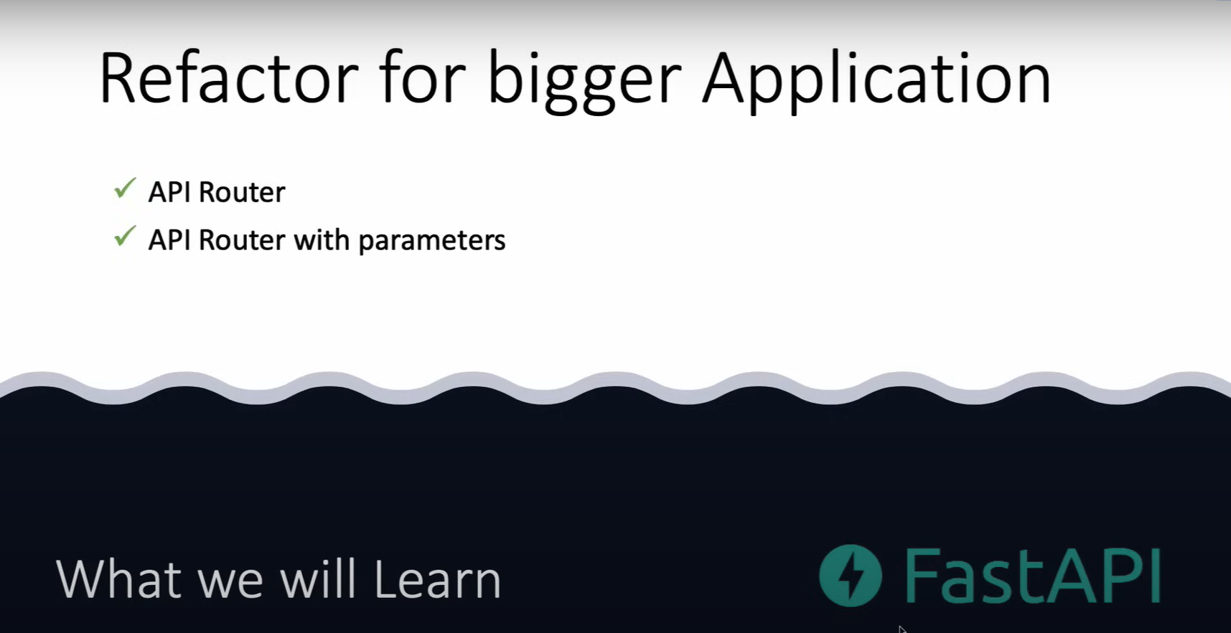

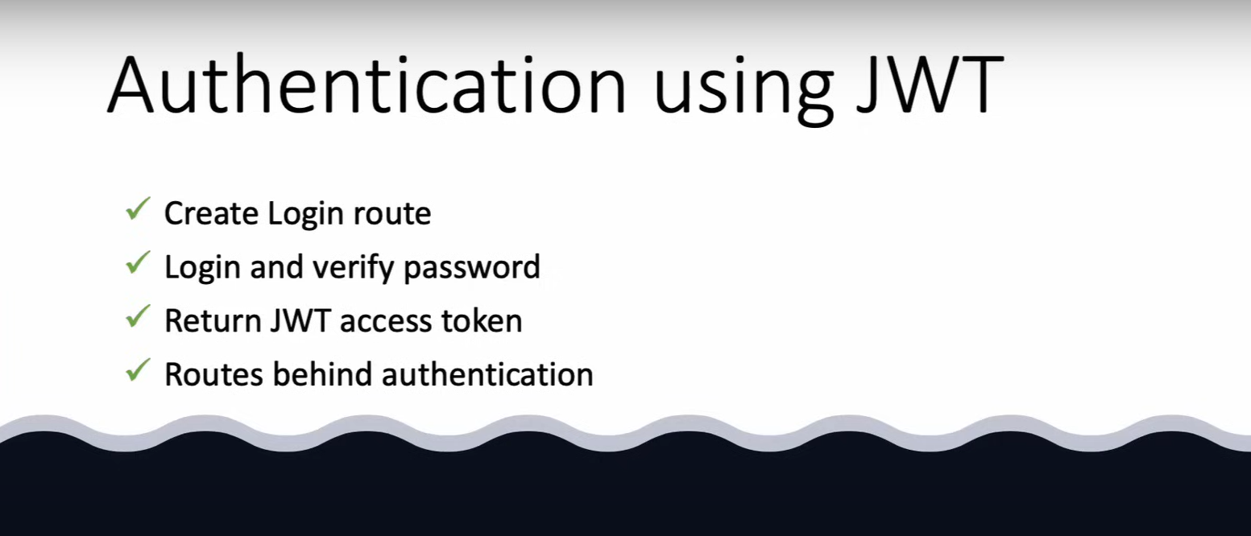

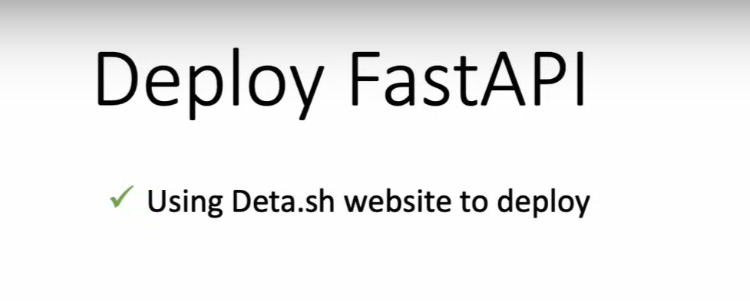

# Install and Setup

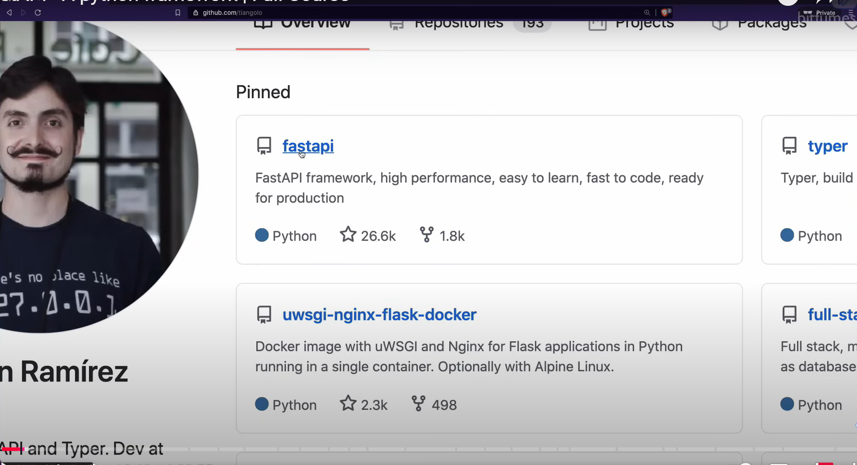

<https://fastapi.tiangolo.com/learn/>

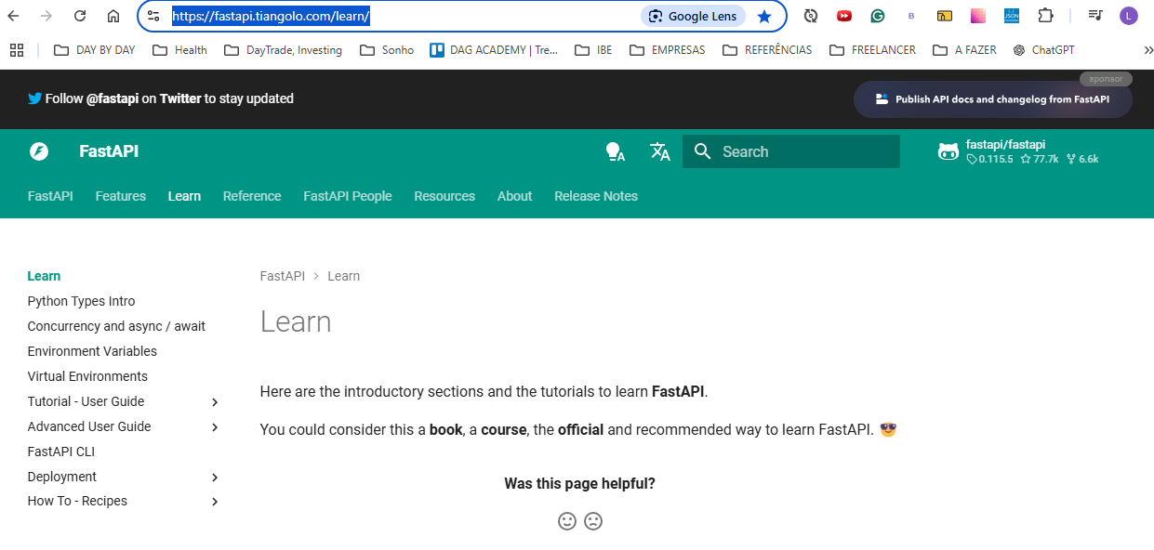

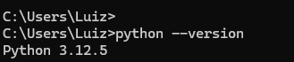

<https://www.python.org/downloads/>

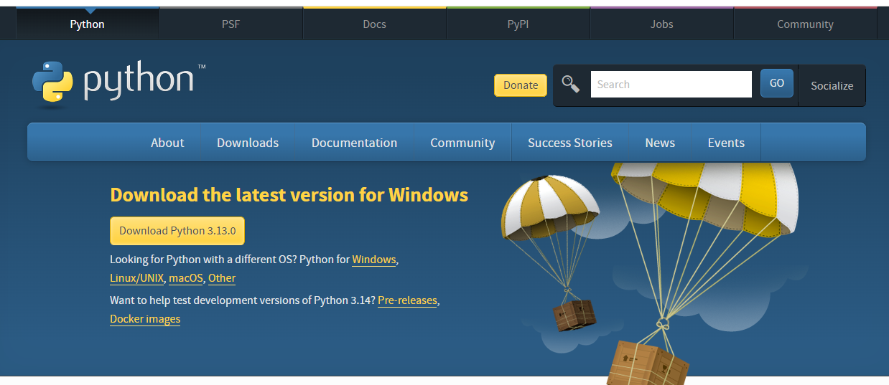

Vamos instalar o fastapi

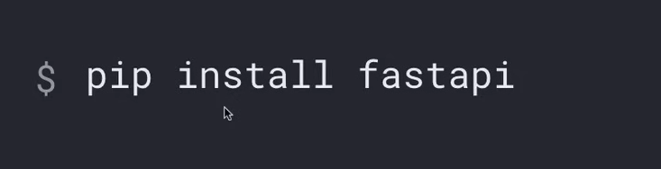

**Pip install fastapi**

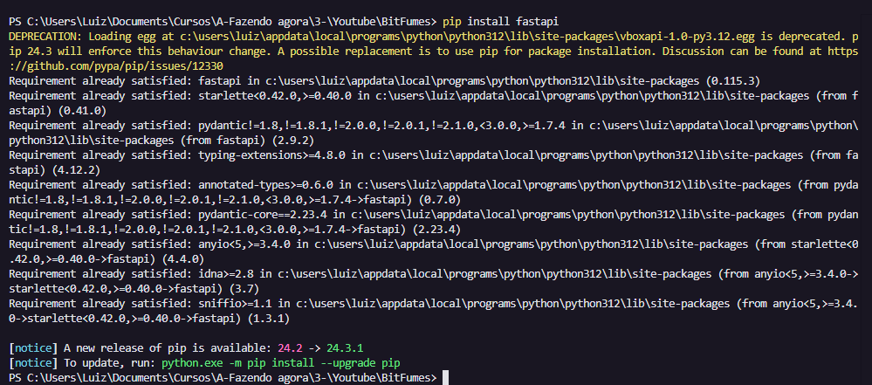

Vamos criar um ambiente virtual para nossos estudos

**python -m venv fastapi-venv**

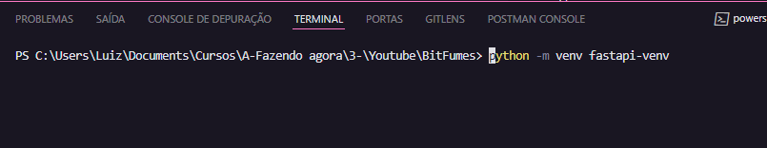

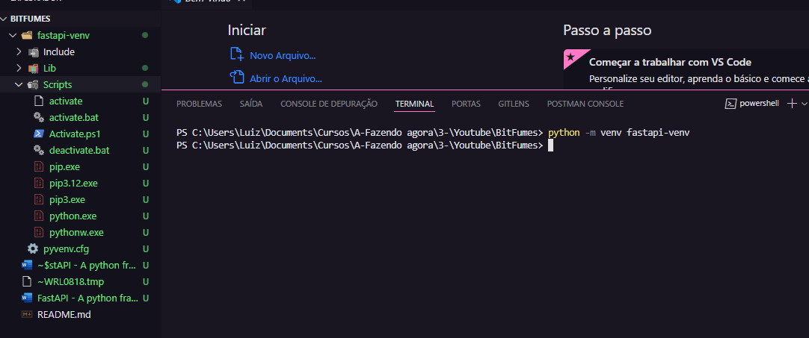

Vamos ativar o ambiente

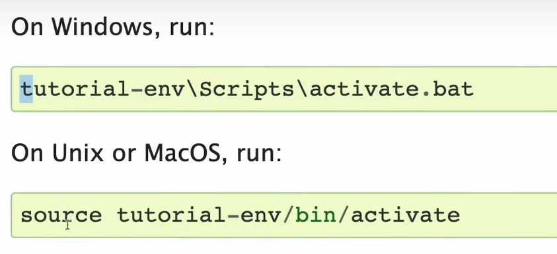

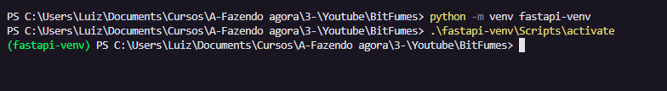

Temos que instalar o fast-api dentro do ambiente virtual

**pip install fastapi**

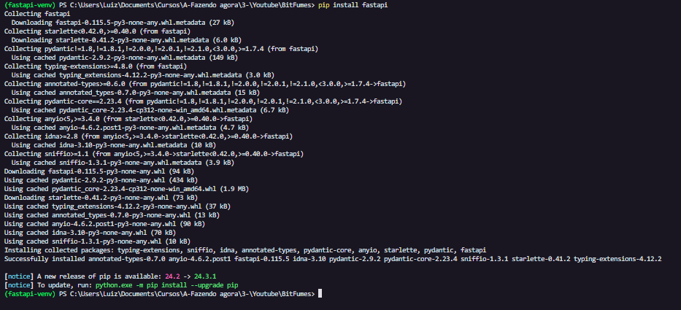

Vamos agora instalar o uvicorn para termos um servidor ASGI

**Pip install uvicorn**

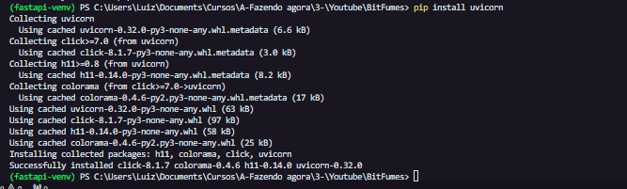

Vamos agora criar um **main.py**

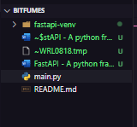

Fazendo o codifo inicial

**from fastapi import FastAPI**

**app = FastAPI()**

**def index():**

**return 'hey'**

Vamos rodar esse hello world co uvicorn:

**Uvicorn main:app –reload**

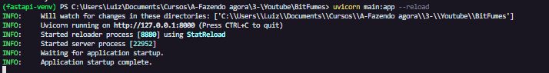

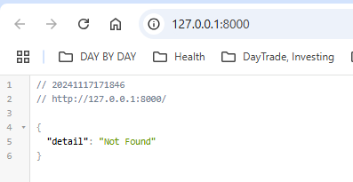

Vamos decorar a função index com o app no Route get

**from fastapi import FastAPI**

**app = FastAPI()**

**@app.get('/')**

**def index():**

**return 'hey'**

Como rodamos com a opção de reload, o fastapi será carregado automaticamente

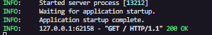

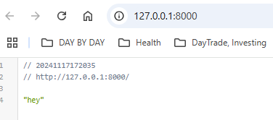

Geralmente quando criamso APIs retornamos uma forma de dafo vamos retornar um json:

**from fastapi import FastAPI**

**app = FastAPI()**

**@app.get('/')**

**def index():**

**return {'data': {'name': 'Luiz'}}**

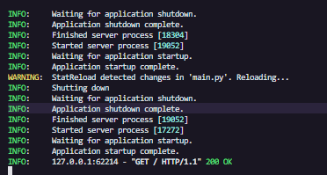

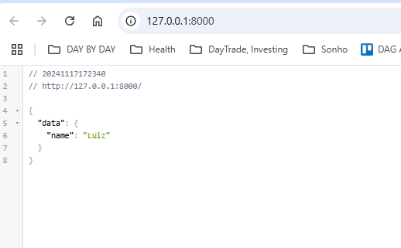

# Break it Down

# Path Parameters

# API DOCS

# Query Parameters

# Request Body

# Debugging

# Database Conection

# Store blog to database

# Load Blog from database

# Exception and status Codes

# Delete a blog

# Response model

# Create a User

# Hash Password

# Show User

# Using Doc Tag

# Realtionship

# API Router

# API Router Pathb Operators

# Blog & User Repository

# Login & Verify Password

# JWT ACCESS TOKEN

# Route Behin Authentication

# Deploy FAST API app